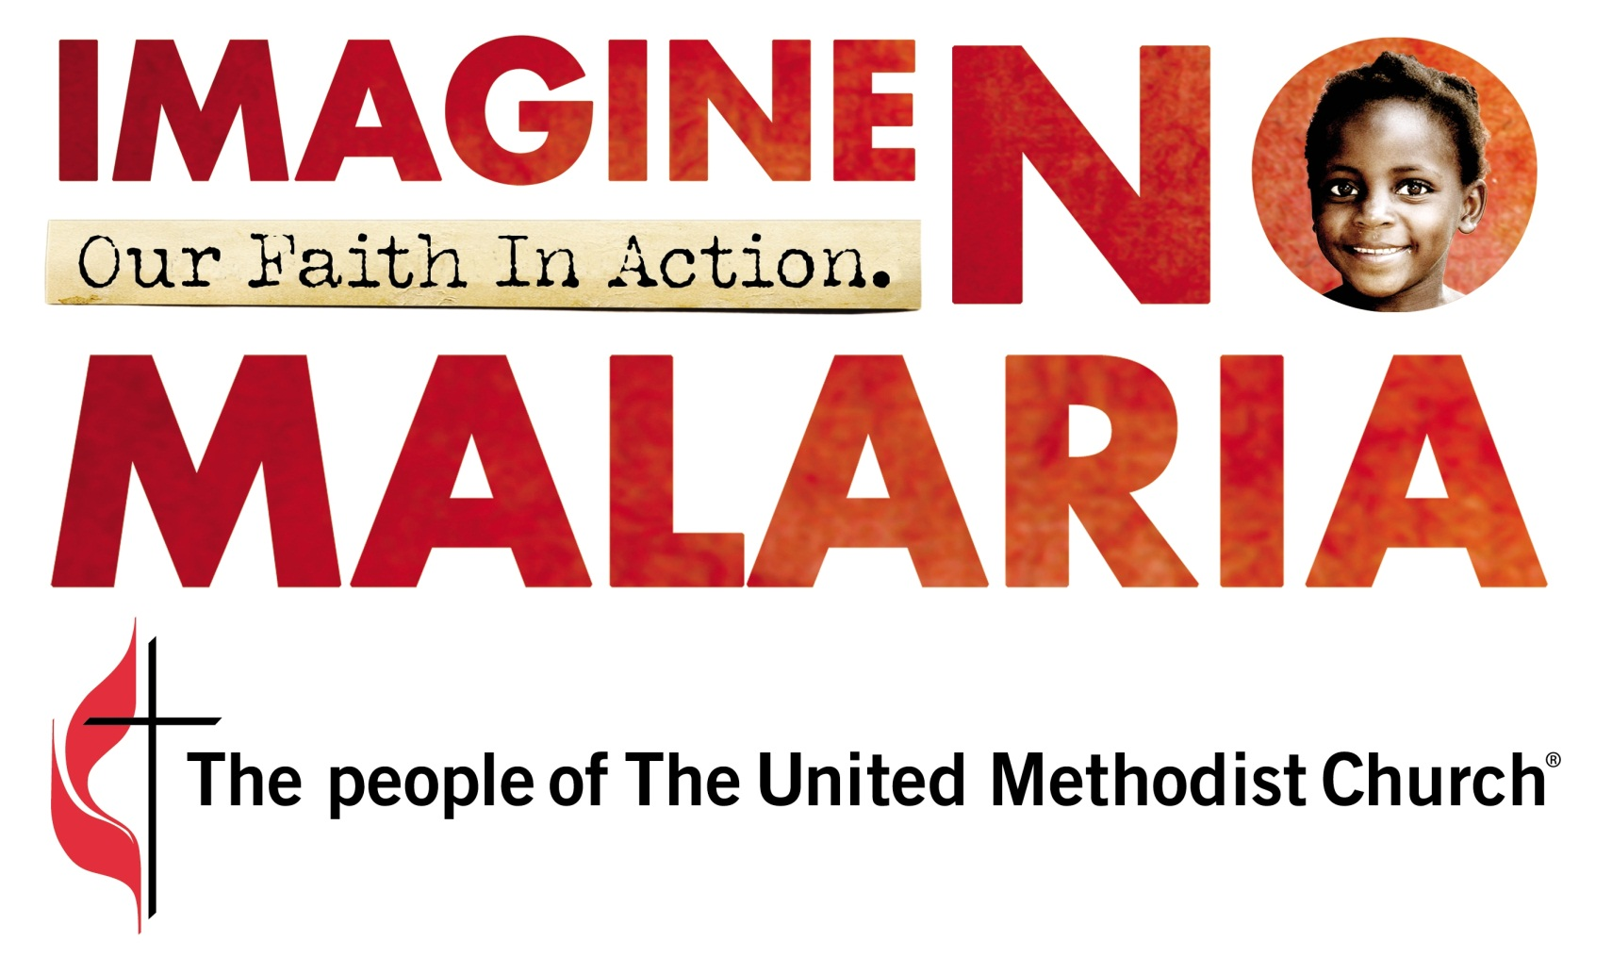

Imagine No Malaria Sermon Resources

“Take care of everyone in time of need. His love never quits. Thank God, who did it all! His love never quits!” –Psalms 136:23-26

Sermon Starter 1—John 6:1-13, NRSV—Feeding the Five Thousand
“After this Jesus went to the other side of the Sea of Galilee, also called the Sea of Tiberias. A large crowd kept following him, because they saw the signs that he was doing for the sick. Jesus went up the mountain and sat down there with his disciples. Now the Passover, the festival of the Jews, was near. When he looked up and saw a large crowd coming toward him, Jesus said to Philip, ‘Where are we to buy bread for these people to eat?’ He said this to test him, for he himself knew what he was going to do. Philip answered him, ‘Six months’ wages would not buy enough bread for each of them to get a little.’ One of his disciples, Andrew, Simon Peter’s brother, said to him, ‘There is a boy here who has five barley loaves and two fish. But what are they among so many people?’ Jesus said, ‘Make the people sit down.’ Now there was a great deal of grass in the place; so they sat down, about five thousand in all. Then Jesus took the loaves, and when he had given thanks, he distributed them to those who were seated; so also the fish, as much as they wanted. When they were satisfied, he told his disciples, ‘Gather up the fragments left over, so that nothing may be lost.’ So they gathered them up, and from the fragments of the five barley loaves, left by those who had eaten, they filled twelve baskets.”
Jesus’ disciples are overwhelmed with the logistical nightmare of feeding the crowd that comes to hear the master teach. They are paralyzed by the enormity of the challenge before them. A boy in the crowd, who has only a little, is willing to share what he has, to put it at Jesus’ disposal. Jesus thanks God, the source of every good thing; serves the people; and creates a feast where no one leaves hungry.
Imagine No Malaria is about moving beyond the things that paralyze us: the size of the problems in Africa, the number imprisoned by poverty, the thousands who will die of malaria every single day, and gives us the opportunity to say, ‘I can’t change all of that, but I can give to save one, 10, 50 or 100 and Jesus, show me a miracle.’ Many have been saved and many more will be saved, but we are reminded of our blessings and our opportunity to use those blessings to offer hope and healing to God’s children, our brothers and sisters.

Sermon Starter 2—1 Corinthians 12:14-20, NRSV and An Inclusive-Language Lectionary—One Body, Many Members
“Indeed, the body does not consist of one member but of many. If the foot would say, ‘Because I am not a hand, I do not belong to the body,’ that would not make it any less a part of the body. And if the ear would say, ‘Because I am not an eye, I do not belong to the body,’ that would not make it any less a part of the body. If the whole body were an eye, where would the hearing be? If the whole body were hearing, where would the sense of smell be? But as it is, God arranged the members in the body, each one of them, as God chose. If all were a single member, where would the body be? As it is, there are many members, yet one body.”
Watching the evening news, you hear of the tragic death of a child from your state, perhaps from abuse, neglect or illness. That story stays with you as you put your head on the pillow and is still with you when you open your eyes in the morning. If the story involved two children who were lost in the same way, it would be all over the radio and papers the next day. If five children died, we would be outraged: “How could this happen?” Fifteen children died in the Columbine High School shooting. We can’t begin to imagine what would happen if we learned an entire elementary school, 600 students, died in the same day, due to avoidable and preventable circumstances. The outcry would shake the foundations of our society.
Yesterday, 2,000 children in Africa died from malaria. Today another 2,000 will die, and again tomorrow, and the next day, and the next day. Where is our outrage? These are God’s children, just as my children are, and just as yours are. We are blessed to live in a place where malaria is not a fear of parents. Shannon Trilli, director of Global Health Initiatives for United Methodist Committee on Relief (UMCOR) said, "Malaria is not just something 'they have in Africa.' We are one church, one family, we all have malaria." We are responsible for all of God’s children. We are fortunate to not fear when our children, grandchildren, and those we care for get a cold. We are blessed and can offer hope and healing to those who live in fear from malaria.
This is a wound on the body of Christ, and the pain affects the whole body. We must do something. Imagine No Malaria gives us the opportunity to act—to heal this wound in the body of Christ.

Sermon Starter 3—Mark 12:41-48, NRSV—The Widow’s Offering
“He sat down opposite the treasury, and watched the crowd putting money into the treasury. Many rich people put in large sums. A poor widow came and put in two small copper coins, which are worth a penny. Then he called his disciples and said to them, ‘Truly I tell you, this poor widow has put in more than all those who are contributing to the treasury. For all of them have contributed out of their abundance; but she out of her poverty has put in everything she had, all she had to live on.’”
Has there ever been a story told as often as this one, used as effectively to motivate people to give? Think about the hearts that have been touched; think of the wealth that has been set free for ministry because of the retelling of the faithfulness of this extravagantly generous woman. Imagine No Malaria is about small gifts that make a big difference. A $10 gift will hardly make us blink, but it could mean life—not just for a child, but for a whole family in Africa.
Imagine No Malaria is our opportunity, your opportunity, the opportunity of the people of the United Methodist Church to make create a sustainable victory over malaria. Luke 12:48 tells us that “From everyone to whom much has been given much, much will be required; and from the one whom much has been entrusted, even more will be demanded.” Let us consider how richly God has given and how richly we might give to others.
+++++
Here’s another approach to the same Scripture. When I was in high school, my pastor did a favor for me—not a big thing, but something which I really appreciated. In my stumbling to say thanks, I said, “If I had $2 million, I’d give you a million!”

Without missing a beat, he asked me, “Do you have $2?”

“Sure” I answered. (Actually, $2 was all I had.)

“Well, then, I’ll take one!”

When I hesitated, he made the point: how easy it seems to give the million dollars we don’t have and what a hard time we have giving what we do have. We don’t need to talk about how we would change the world if we had the money of a rock star, a professional athlete, or a wealthy businessperson. Imagine No Malaria reminds us that the power to change the world, to save lives, is in our pocket right now.
Complete Sermon—John 21:1-12, NRSV—The Great Catch
“After these things Jesus showed himself again to the disciples by the Sea of Tiberias; and he showed himself in this way. Gathered there together were Simon Peter, Thomas called the Twin, Nathanael of Cana in Galilee, the sons of Zebedee, and two others of his disciples. Simon Peter said to them, ‘I am going fishing.’ They said to him, ‘We will go with you.’ They went out and got into the boat, but that night they caught nothing.
“Just after daybreak, Jesus stood on the beach; but the disciples did not know that it was Jesus. Jesus said to them, ‘Children, you have no fish, have you?’ They answered him, ‘No.’ He said to them, ‘Cast the net to the right side of the boat, and you will find some.’ So they cast it, and now they were not able to haul it in because there were so many fish. That disciple whom Jesus loved said to Peter, ‘It is the Lord!’ When Simon Peter heard that it was the Lord, he put on some clothes, for he was naked, and jumped into the sea. But the other disciples came in the boat, dragging the net full of fish, for they were not far from the land, only about a hundred yards off.
“When they had gone ashore, they saw a charcoal fire there, with fish on it, and bread. Jesus said to them, ‘Bring some of the fish that you have just caught.’ So Simon Peter went aboard and hauled the net ashore, full of large fish, a hundred fifty-three of them; and though there were so many, the net was not torn. Jesus said to them, ‘Come and have breakfast.’ Now none of the disciples dared to ask him, ‘Who are you?’ because they knew it was the Lord.”

In the motion picture “The Guardian,” Kevin Costner plays Ben Randall, a living legend in the Coast Guard’s elite team of rescue swimmers. Amid the worst storms and conditions, Randall and his crew go out in their helicopter, jump 20 feet into sometimes-freezing water and miraculously pluck victims of wrecks, capsized boats and ship fires from certain death.

In the academy where these selfless rescue teams are trained, Costner’s aging character holds every record, but a young recruit, Jake Fisher (played by Ashton Kutcher), is bent on replacing Ben Randall’s name on the record boards. One record, though, is not posted anywhere, and is only spoken of in hushed voices: the number of lives Randall has saved in his amazing career. Some say 200; others say 300; no one knows for sure.

Early in the film, Randall’s friend and fellow crew member suggests it may be time for them to retire. “And do what?” Randall asks.

“We could go fishing,”

“Where’s the fun in that?” Randall replies as they go off to sea, dangling their line into the swelling waves so they can haul a new day’s catch of human lives into their vessel.

Let’s go back 2,000 years to the shores of the Sea of Galilee. Peter, Andrew, James, John and other disciples decide that, in the face of the turmoil around Jesus’ death, empty tombs and all the rest, it is a good time to go fishing. Remember: When Jesus called those four, they were beside the sea mending their nets. It seems finding those nets they left behind might not be a bad career move. The nets are a key ingredient in their livelihood. The fisher releases the net from one side of the boat, rows in a circular motion and pulls in the net to determine if the fishing is successful. Often the answer to that question means survival or devastation for the fisher’s family.

These confused, dazed disciples have fished all night, and they haven’t caught so much as a mackerel. Everything is in chaos, and now even their nets don’t work. Suddenly a figure calls to them from the shore, asking if they have caught any fish. Talk about adding insult to injury! When they answer honestly that they haven’t caught a single fish, the mysterious person tells them to cast their nets instead on the right side of the boat. You know what happens.

I’d like to share the story of another kind of net that can mean survival or devastation today: a bed net, given to families in Africa. It’s a simple method to reduce the spread of malaria and other diseases transmitted by mosquitoes.

The United Methodist Church has fought malaria for years. Our denomination’s work intersected with the efforts of the United Nations and the Bill and Melinda Gates Foundation, which also has made the eradication of this disease a priority, and a relationship began to form. In 2006, the United Methodist Church formed “Nothing But Nets,” which was a mission to provide bed nets to Africa. Today, the United Methodist Church is going beyond nets to meet the needs and create a sustainable victory over death from malaria. Imagine No Malaria is the global mission of the people of the United Methodist Church to provide prevention, treatment, education, and communication. The call is simple: $10 saves a life. The goal is simple: eliminate death and suffering from malaria.
The United Methodist Church was asked to partner with leaders in global health because of the work the Church has already been doing for more than 160 years in Africa. The United Methodist Church has been serving Africa where the road ends for generations: where the road ends, the cross and flame remain. The Bill and Melinda Gates Foundation, the United Nations Foundation, and the Global Fund knew the effective work the United Methodist Church was already doing in Africa. And the global health leaders recognized the potential impact of 11 million United Methodists joined together to save lives and eliminate death and suffering from malaria.

For some people this alliance may seem a little strange. Yet we need only look at the Gospel accounts of the travels and associations of Jesus to see he constantly crossed the boundaries of what seemed “acceptable affiliations” in his day and culture. He went where others wouldn’t go, and he ate and hung out with persons that others in the religious establishment wouldn’t touch with a 10-foot pole.

When we realize we dwell in a world where one small part of the population lives in abundance, while others live in a desperate struggle for survival, we could conclude that we need new strategies, tactics and alliances if we are going to make a difference.

It may be long past time for us to hear Jesus’ call to cast our nets on the other side of the boat, to take what has become the familiar business of ministry and to find new ways to represent Christ in a world in urgent need of Christ’s intervention.

Let’s return to the film “The Guardian,” which I mentioned earlier, and to Ben Randall, the rescue swimmer. Leaving behind a world of relative comfort, time after time Randall dons the wet suit and the rescue gear, boards the Coast Guard helicopter and makes that 20-foot drop into raging, turbulent, icy waters. When the helicopter drops its net (a metal basket, in this case), Randall is the one in the water who sees that the victims make their way to the basket. He is the one who decides who gets picked up first, and often that determines who survives.

In a powerful scene near the end of the film, as Randall appears to be “passing the mantle” to his former student Jake Fisher, the new rescue swimmer asks about that mysterious number, the one spoken of in hushed voices at the Coast Guard elite training school. Is it 200 lives, or 300 or more? “Twenty-two” is the somber answer. Young Jake is taken aback; you can see the wheels turning as he imagines how easily that record is broken. Ben’s explanation shakes him back to reality: “That’s the count of the ones I didn’t save.” In the powerful silence that follows, the implications are clear: Ben Randall never bothered to count the hundreds of souls he snatched from a watery death, but he carries the weight of every individual life that might have made it but didn’t.

In the time it has taken for me to share these words, about 20 children have died from malaria. If we listed the needs necessary to protect all of the children, women and men who need them, the number would be staggering. We do know what we can do: if each us gave just $10 that would save a life, and maybe then you could also consider how many more lives you are capable are saving. Think of how many we can save together! We can do it for the children we can save. We can do it for the ones we cannot save, because that number weighs heavy on our hearts.

Or we could do it for ourselves, for our ongoing relationship with Christ is linked to our ability to be connected to those with whom Christ would connect. It’s part of my salvation-relationship with Christ. I could give to save a life, or 10, or 50, or 100, thanks to Christ because He has transformed my life.

In the end, I must acknowledge that it was me in that water, in the midst of stormy waves, facing death, until Jesus plunged into the water and swam my way. My rescue swimmer. My Savior. He made sure I made it into the net, for the thought of even one lost weighs heavy on his heart. Can I do anything less?

