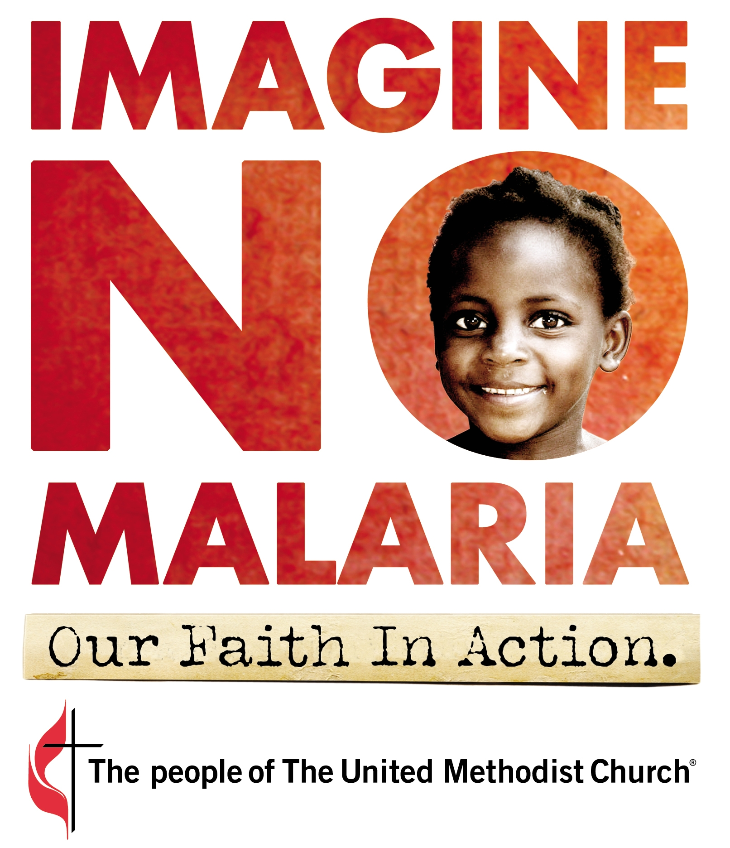
Bible Study or Sunday School Lesson
Mission Focus – Imagine No Malaria

PURPOSE:

Discovering that being a good neighbor means we cannot pass by those who are in need.

MATERIALS:

Bibles, Small Group Discussion Questions, Imagine No Malaria DVD, $10 bill, Markers, 4 Pieces of Butcher Paper Taped to Wall or Easels, Malaria Facts (enough for each participant), Imagine No Malaria Donation Envelopes

INTRODUCTION ICE BREAKER:
{3-5 Minutes}

Leader: Hold out change or place it on a table. This is $10. Is it valuable? What can you buy with $10?

Leader: How easy would it be for you to give $10 away?

Leader: What is the most valuable ‘thing’ $10 can purchase?

Leader: If I told you $10 could save the life of a child, would you believe me? Why or why not?

Leader: Through Imagine No Malaria $10 can save a life. Just $10 provides prevention, education, treatment, and communication support for a continent that suffers from malaria. Through our church $10, has the power to protect a life from a deadly disease called malaria. How many lives might you be able to save? How many $10 bills can you sacrifice for the gift of life?

INTRODUCTION

Leader: The focus of today’s lesson is our Imagine No Malaria campaign. The United Methodist Church is part of a global effort to eliminate deaths from malaria by the year 2015. Our goal is to raise $75 million to be used in Africa to fight malaria through the work of the United Methodist churches, health clinics and partner groups who are already there.

GROUP PARTICIPATION:
{10-15 Minutes}

Leader: Let’s learn a little bit more about malaria and why protecting children from this disease is remarkably possible. Put individuals in threes or fours, unless the group is very small. Distribute different malaria facts to each group. Ask them to write three new facts they have learned on their pieces of butcher paper [They do not need to copy the facts verbatim from the sheet]. Have them discuss the facts in their small group. Was there anything surprising? Did anyone in the group have additional information to share? Leader: When each group has finished, ask them to reveal their findings to the entire class.


Facts About Malaria

Fact: Malaria is caused by the plasmodium parasite, spread by the bites of infected mosquitoes.
If not treated promptly with effective medicines, malaria is often fatal.
Fact: Every 60 seconds a child in Africa dies of malaria; that’s 2,000 young lives every day.
Fact: Malaria kills nearly 700,000 people each year. Ninety percent of these deaths occur in
sub-Saharan Africa.
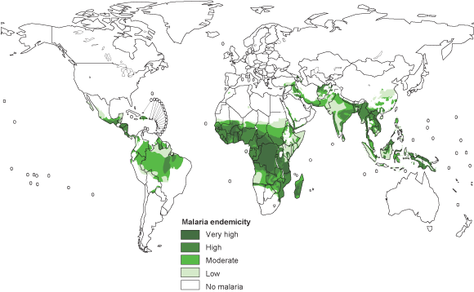
Fact: Malaria’s symptoms include fever, chills, vomiting, convulsions, severe pain in joints and muscles, and diarrhea. These are caused because the parasite kills red blood cells, reducing oxygen in the bloodstream. If not treated properly, malaria can lead to death.
Fact: Malaria is a completely preventable and treatable disease.
Fact: Prior to 1951, Malaria was a serious public health problem in the United States. A comprehensive effort from 1947-1951 virtually eradicated malaria in this country.
Fact: Malaria is a disease of poverty.
It severely impacts those who cannot afford treatment or have limited access to healthcare, leading to a detrimental effect on attendance at workplaces and schools.
Fact: Long-lasting insecticide treated bed nets (LLIN’s) are the simplest, most cost-effective way to prevent malaria. However, to eliminate deaths caused by this disease, our efforts must include prevention and education programs, development and rehabilitation of United Methodist hospitals and clinics, and training programs for medical outreach workers. This comprehensive plan will be supported by United Methodist Health Boards recruited and trained in each UMC Central Conference.
Fact: Malaria rates in parts of Africa are on the decline: after increasing net coverage and access to medication, the under-five mortality rate in Rwanda dropped by 66% in two years. In Eritrea, the overall morbidity rate decreased by 80% in just four years using similar methods.
GROUP DISCUSSION:
{15-20 Minutes}

Leader: Malaria is a parasite that has a complicated life cycle. Part of that cycle occurs in humans and the other occurs in mosquitoes. In order for the malaria parasite to continue being spread, there must be a certain number of mosquitoes in a population and a certain number of people who are infected with this disease. Reducing the mosquito population and simultaneously treating infected people will disrupt the parasite’s life cycle. That is why prevention and treatment are critical in our effort to eliminate deaths.

Leader: Let’s discover all the different ways the church is fighting malaria. Show Imagine No Malaria Overview (on the DVD. {3 minutes}

Leader: What are the four ways we are fighting this disease in Africa? [WAIT FOR ANSWER]

Leader: Prevention, treatment, communication, and education are the tools we are using to serve our neighbors in Africa who desperately need medical attention and other resources to protect themselves from this disease.

Leader: Let’s discuss in smaller groups how God values our service to others using a parable Jesus once told. Distribute questions to each group.

SMALL GROUP DISCUSSION QUESTIONS:
Luke 10: 27-31

What was the Priest’s reaction to the injured man? Why did he pass by? What does his action reveal to us about his character (Christ’s definition of a neighbor)?

Luke 10: 27-32

What was the Levite’s reaction to the injured man? Why did he pass by? What does his action reveal to us about his character (Christ’s definition of a neighbor)?

Luke 10: 27-35

What was the Samaritan’s reaction to the injured man? He did not pass by; what does his action reveal to us about his character (Christ’s definition of a neighbor)?

Luke 10: 27-37

Who was the neighbor? Why was he considered to be the neighbor; how were his actions different from the other characters in the parable? What is the significant of Jesus telling a story in which the hero of the story is from an area which was despised by most Jewish people. What lessons does this story offer to those who want to participate in Jesus’ ministry of healing today?

CLOSING DISCUSSION AND PRAYER: {15-20 Minutes}

Leader: What did the Priest do when he saw the injured man? What about the Levite? [WAIT FOR ANSWERS]

Leader: These people of God saw a man half-beaten to death, lying in the road. Blood was everywhere. They knew he was likely to die if they did not stop, and yet, they chose to walk to the other side of the street. They looked away and passed by.

Leader: What did the Samaritan do? [WAIT FOR ANSWERS]

Leader: The Samaritan did not pass by. He saw the injured man’s face, his bruises, and his blood. He was so moved that he stopped. He showed mercy. This response made him a neighbor.

Leader: Was the response of the Samaritan free? What did it cost him? [WAIT FOR ANSWERS]

Leader: Possible answers: 1) Time – it slowed his trip. 2) Risked his Safety – The Jericho Road was known to be a road where people were robbed. 3) His Money – He gave the innkeeper “two denarii”. A denarius equaled one day’s wage for a laborer in Jesus’ day. The Samaritan gave up two days worth of wages to care for a man he did not know. An equivalent today, would be giving $100-300 or more, depending on your salary.

Leader: How might the story of the Good Samaritan relate to our church’s Imagine No Malaria campaign?

Leader: Let’s take some time now to talk about this question and any other questions class members might have about Imagine No Malaria. Take 5-10 minutes to have a general discussion. Be sure to leave five minutes at the end of class to share the following story, and to ask your class members to consider a gift to Imagine No Malaria.

Leader: Pick a volunteer to read the following story.

Domingos Antonic was 8 months old when his parents brought him to the hospital in Malanje, Angola. His fever was raging, foam was all over his lips, and he lay completely still in his mother’s arms. He was infected with malaria. He had been sick for days. At this point, he only weighed fifteen pounds. While his parents made the right choice to bring Domingos to the hospital, the medical staff did not have the necessary supplies to save him in his late stage of malaria. It was too late. His parents watched helplessly as their son died from a preventable and treatable disease. (Interpreter Magazine, July/August 2009, p.15-17)

Today, the parents of 2,000 children will join in the Antonic’s despair, watching their babies die of malaria.

Tomorrow, it will happen again.

Leader: We know a need exists. Thousands of children are losing their lives each day to a preventable and treatable disease. We as United Methodists are working to provide the resources families need to protect themselves.

Leader: Our church understands the need. Our church is not looking away. Right now, we are there…in the road…looking at the faces of children who desperately need help. The church has stopped to help.

Leader: Protecting children from malaria is not free, it costs money. However, for most of us it is affordable. A life is saved by just $10. Consider how many you are capable of saving.

Closing Prayer: Thank you, God, for coming to live among us in the form of Jesus. Thank you for giving us the example of one who cares about those in need, especially those who are ill. You have given us the ability to make a difference in the lives of children in Africa and their families. We know you have called us to be neighbors to them and to love them as we love ourselves. Help us, Lord, to be good neighbors. Break our hearts for them, so we do not pass by. AMEN.

BEYOND THE CLASSROOM:

- Check Out the Website for Imagine No Malaria to Learn More about this Ministry www.imaginenomalaria.org

- Follow Holston Conference’s Imagine No Malaria initiative on Twitter
www.twitter.com/NoMalariaHC

- Follow Holston Conference’s Imagine No Malaria initiative no Facebook
www.facebook.com/ImagineNoMalariaHolston

- Engage Your Congregation and Community by Raising Awareness
- Youth– Sleep Out to Stamp Out Malaria (Camping out Under Nets)
- Documentary Viewing – “Killer in the Dark” (DVD resource or order at www.imaginenomalaria.org/resources)
- Host a House Party – share with friends, learn about malaria, and save lives

